H.T No
Regulations:
A19

Sreenidhi Institute of Science and Technology
(An Autonomous Institution)
Code No: 7M214 Date: 20-July-2021 (FN)

M.Tech I-Year II-Semester External Examination, July - 2021 (Supplementary)
ADVANCED FINITE ELEMENT ANALYSIS(TE)

Time: 3 Hours Max.Marks:70

Note: a) No additional answer sheets will be provided.
b) All sub-parts of a question must be answered at one place only, otherwise it will not be valued.
c) Missing data can be assumed suitably.

ANSWER ANY 5 OUT OF 8 QUESTIONS. EACH QUESTION CARRIES 14 MARKS.

Bloom's Cognitive Levels of Learning (BCLL)

Remember | L1 | Apply | L3 | Evaluate | L5
Understand | L2 | Analyze | L4 | Create | L6

 |  |  | BCLL | CO(s) | Marks
1. |  | Determine the displacement field, stress and support reactions in the body. Take E as 20 GPa. In the Fig 1. given below, a load P=60 KN is applied as shown.  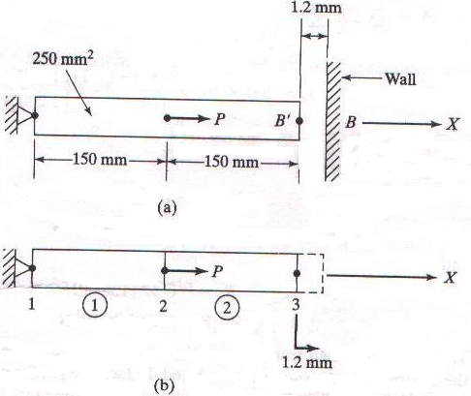 | L5 | CO1 | [14M]
2. |  | Determine the displacements and stresses in the bars For the truss shown in Fig.2.  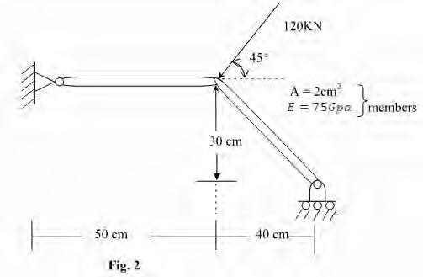 | L5 | CO2 | [14M]
3. |  | Define with neat sketch, Iso-parametric, Super-parametric and Sub-parametric elements | L2 | CO3 | [14M]
4. |  | Discuss in detail about Tetrahedron element and their properties and advantages. Derive the [B] matrix, strian and stresses for four nodded Tetrahedron element. | L4 | CO4 | [14M]
5. |  | Determine the temperature distribution through the composite wall shown in Fig 3, when convection heat loss occurs on the left surface. Assume unit area. Assume wall thickness.  t₁ = 4cm, t₂ = 2cm, k₁ = 0.5w/cm0c, k₂ = 0.05w/cm⁰c,  h= 0.1w/cm² K and Tα= -5⁰c  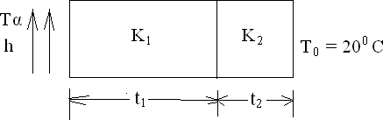  Fig 3 | L5 | CO5 | [14M]
6. |  | Evaluate the lowest Eigen value and the corresponding Eigen mode for the beam shown in Fig 4 below  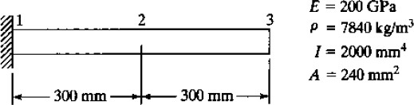  Fig 4 | L5 | CO6 | [14M]
7. | a) | Differentiate between planar frame element and space frame element | L3 | CO1 | [7M]
 | b) | Enumerate the importance of Jacobian matrix in FEM with an example | L4 | CO2 | [7M]
8. | a) | Write the mass matrix for truss element with an example | L2 | CO4 | [7M]
 | b) | Explain plane stress condition. | L2 | CO5 | [7M]
-- 00 -- 00 –

